

COMSATS
University Islamabad, Lahore Campus

Course Title: | Design Patterns |  |  |  | Course Code: |  | SED304 | Credit Hours: | 3(2,1)
Resource | Shaina Ashraf |  |  |  | Programme |  | BS Software Engineering
Semester: | 7th | Batch: | SP18-BSE | Section: | Elective |  | Date:
Time Allowed: | 3 hours |  |  |  | Maximum Marks: |  |  | 50
Student’s | Muhammad Abubakar Ijaz |  |  |  | Reg. No. | CIIT/ SP18-BSE -031-C

S3 Sessional Examination (Theory) – Spring 2021 Important instructions:

- Assume java/c++ programming language is considered wherever applicable.
- Don’t forget to mention your name and Reg.No above.
- Copy and paste code here in document and submit on MS teams.
- For submission, use last 15 minutes and MS teams submission will be closed at 5:00 pm and no late submission will be considered on email or other way.

Question 1: Answer the following questions: [5+5+5+5=20]

- Define Adapter pattern and give example from real world. Also, define two variations of the
Adapter pattern implementation. [5]
Ans : Adapter pattern is a Structural Design pattern, Like any adapter in the real world it is used to be an interface, a bridge between two objects. It Convert the interface of a class into another
interface clients expect. Adapter lets classes work together that couldn’t otherwise because of incompatible interfaces. Wrap an existing class with a new interface. Also Known As Wrapper.
We take Example of a charger of Nokia which can be attached to two different models of mobile of Nokia but we also have another mobile which is Samsung and that charger cannot be attached to Samsung so we have to create an adapter plug which is attached to Nokia charger and it will charge our Samsung mobile.
Two Variations of Adapter Pattern are :
Class Adapters :
Use multiple inheritance to compose classes
Object Adapters :
Object adapters use a compositional technique to adapt one interface to another.

- Define Open-Closed Principle. Which design patterns are potentially based on this principle?
[5]
Ans : The open-closed principle states "software entities (classes, modules, functions, etc.) should be open for extension but closed for modification"; that is, such an entity can allow its behavior to extend without modifying the source code.
The Design Patterns based on these principles are :
- Decorator Pattern
- Strategy Pattern
- Builder Pattern
- Adapter Pattern
- List few distinct advantages of factory pattern over constructors. [5]
Ans : The factory method is a smart way to create objects in Java and provides several advantages over the traditional approach to creating objects using builders in Java. It can also improve code quality by making the code more readable, less coupled, and improves performance through caching.
On the other hand, using the constructor, you tightly bind any client (using that class) to the class itself. Any change of class, eg. the introduction of a new constructor or a new implementation will require changes almost everywhere.
We use the factory method template when

- a class cannot anticipate the object class it must create
- a class wants its subclasses to specify the objects it creates
- the classes delegate responsibility to one of the helper subclasses and you want to locate the knowledge of the delegated helper subclass

- What is the use of observer design pattern and how do you handle memory leakage issue in oberver design pattern? [5]
Ans :
- Observer pattern is one of the behavioral design pattern.
- Observer design pattern is useful when you are interested in the state of an object and want to get notified whenever there is any change.
- The Observer pattern is also a key part in the familiar model–view–controller (MVC) architectural pattern.
- In observer pattern, the object that watch onthe state of another object are called Observer
- and the object that is being watched is called Subject.
- Observer pattern is used when there is one-to-many relationship between objects
- such as if one object is modified, its dependent objects are to be notified automatically.
- You can add and remove observers at any time.
We use MVC Model with Observer Pattern to remove memory leakage issue.
Hashtable<String,String> info = new Hashtable<String,String>();
^ To be used in product class ^
And the downward code in set methods :
info.put("id",id);
setChanged();
notifyObservers(info);
In View Class we will use the Override method of Oberver:
@Override
public void update(Observable o, Object arg) {
System.out.println("Updating Method is being called and the new Value is : "+ arg);
printproductdetails(((Hashtable<String,String>)arg).get("id"),((Hashtable<String,String>)arg).get("name"),((Hashtable<String,String>)arg).get("price"),
((Hashtable<String,String>)arg).get("photo"),((Hashtable<String,String>)arg).get("quantity"),((Hashtable<String,String>)arg).get("model"));
}
And in main demo class we will call the function :
model.addObserver(view);

Question 2: An online website i.e., X-programming-site allows users to create and execute programs using their favorite programming language. It provides you with plenty of programming language options (Java, C, CPP, Ruby, PHP). You choose one, write a program with it and execute it to see the result.
But now the site has started losing its users, the reason being the slowness of the site. The users are not interested in it anymore. The site is very popular and sometimes there could be more than thousands of programmers using it. Because of that, the site is crawling.
A code (core programming of the site which allows users to run and execute their program) is given below, by considering it attempts following parts: [2+8=10]

- Propose a solution of above problem (Justify answer) [2]
Flyweight pattern is primarily used to reduce the number of objects created and to decrease memory consumption and increase performance.
This type of design pattern comes under structural pattern as this pattern provides ways to decrease object count thus improving the object structure of application.
Each "flyweight" object is divided into two pieces:
Intrinsic State :Intrinsic state is stored (shared) in the Flyweight object.
Extrinsic state: Extrinsic is stored or computed by client objects, and passed to the Flyweight when its operations are invoked.
- Do you think there is issue in its core programming (If then update code)? [8]
import java.util.HashMap;
import java.util.Map;

public final class PlatformFactory {

private static Map<String, Platform> map = new HashMap<>();
private PlatformFactory(){
throw new AssertionError("Cannot instantiate the class");
}

public static synchronized Platform getPlatformInstance(String platformType){
Platform platform = map.get(platformType);
if(platform==null){
switch(platformType){
case "C" : platform = new CPlatform();
break;
case "CPP" : platform = new Cplusplus();
break;
case "JAVA" : platform = new JavaPlatform();
break;
case "RUBY" : platform = new Ruby();
break;
case "PHP" : platform = new PHP();
break;

}
map.put(platformType, platform);
}
return platform;
}

}

public class Code {

private String code;

public String getCode() {
return code;
}

public void setCode(String code) {
this.code = code;
}

}
public class JavaPlatform implements Platform {

public JavaPlatform(){
System.out.println("JavaPlatform object created");
}

@Override
public void execute(Code code) {
System.out.println("Compiling and executing Java code.");
}

}
public class CPlatform implements Platform {

public CPlatform (){
System.out.println("C-Platform object created");
}

@Override
public void execute(Code code) {
System.out.println("Compiling and executing C code.");
}

}
public class Cplusplus implements Platform {

public Cplusplus (){
System.out.println("C++ object created");
}

@Override
public void execute(Code code) {
System.out.println("Compiling and executing C++ code.");
}

}
public class Ruby implements Platform {

public Ruby (){
System.out.println("Ruby object created");
}

@Override
public void execute(Code code) {
System.out.println("Compiling and executing Ruby code.");
}

}
public class PHP implements Platform {

public PHP (){
System.out.println("PHP object created");
}

@Override
public void execute(Code code) {
System.out.println("Compiling and executing PHP code.");
}

}

// Note: The other platform specific classes are similar to the JavaPlatform ,CPlatform class, already written above ClientDemo.java:
Code code = new Code();
code.setCode("C Code...");
Platform platform = PlatformFactory.getPlatformInstance("C");
platform.execute(code);
System.out.println("-------------------------------------");
code = new Code();
code.setCode("C Code2...");
platform = PlatformFactory.getPlatformInstance("C");
platform.execute(code);
System.out.println("-------------------------------------");
code = new Code();
code.setCode("JAVA Code...");
platform = PlatformFactory.getPlatformInstance("JAVA");
platform.execute(code);
System.out.println("-------------------------------------");
code = new Code();
code.setCode("JAVA Code2...");
platform = PlatformFactory.getPlatformInstance("JAVA");
platform.execute(code);
System.out.println("-------------------------------------");
code = new Code();
code.setCode("RUBY Code...");
platform = PlatformFactory.getPlatformInstance("RUBY");
platform.execute(code);
System.out.println("-------------------------------------");
code = new Code();
code.setCode("RUBY Code2...");
platform = PlatformFactory.getPlatformInstance("RUBY");
platform.execute(code);
code = new Code();
code.setCode("PHP Code...");
platform = PlatformFactory.getPlatformInstance("PHP");
platform.execute(code);
System.out.println("-------------------------------------");
code = new Code();
code.setCode("PHP Code2...");
platform = PlatformFactory.getPlatformInstance("PHP");
platform.execute(code);
code = new Code();
code.setCode("CPP Code...");
platform = PlatformFactory.getPlatformInstance("CPP");
platform.execute(code);
System.out.println("-------------------------------------");
code = new Code();
code.setCode("CPP Code2...");
platform = PlatformFactory.getPlatformInstance("CPP");
platform.execute(code);

Question 3: Assume that there is a blog and users register to that blog for update. When a new article is posted in the blog, it will update the registered users saying a new article is posted so that the user can access the blog and read the new article.
By considering above scenario, attempt following parts: [2+2+6=10]
- Propose appropriate design pattern [2]
We will use Observer Pattern in this scenario.
- Draw Class diagram [2]
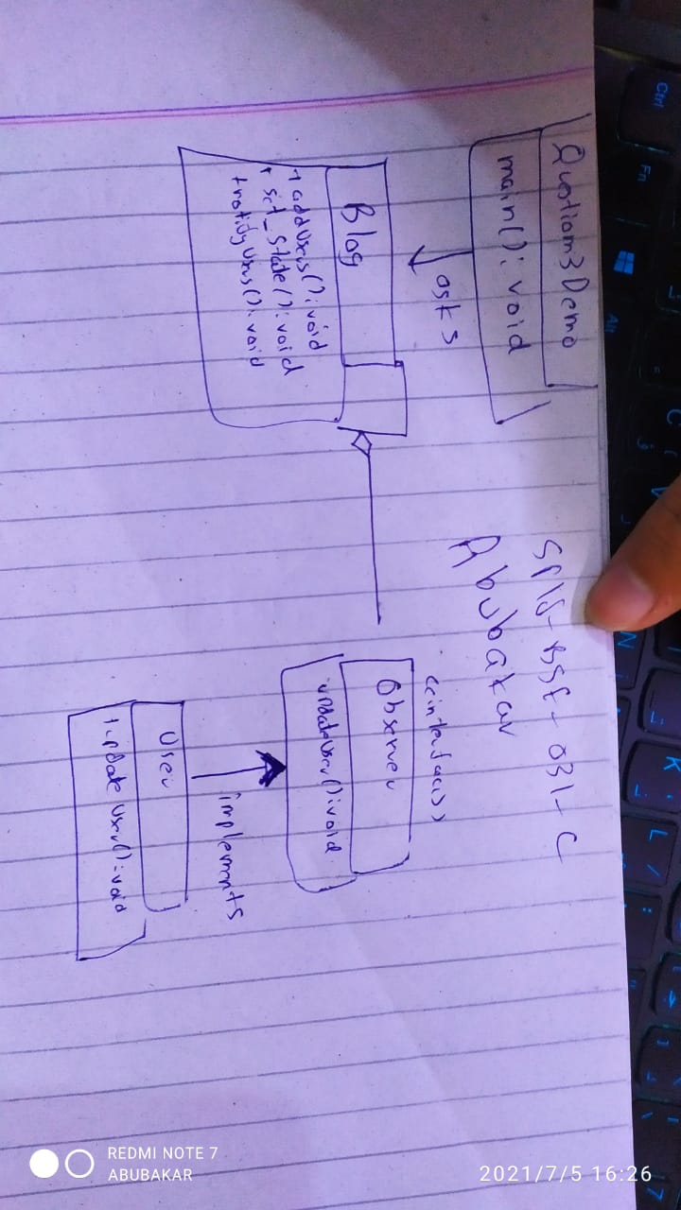
- write code for above scenario [6]
Question3TerminalAbubakarObserverDemo.java
/*
* To change this license header, choose License Headers in Project Properties.
* To change this template file, choose Tools | Templates
* and open the template in the editor.
*/
package question3.terminal.abubakar.observer.demo;
import java.util.*;
/**
*
* @author Abubakar
*/
public class Question3TerminalAbubakarObserverDemo {
/**
* @param args the command line arguments
*/
public static void main(String[] args) {
// TODO code application logic here
Blog blog = new Blog();

User u1 = new User("Abubakar SP18-BSE-031-C : ");
User u2 = new User("Omer : ");

blog.addUser(u1);
blog.addUser(u2);

System.out.println("Adding Weather Blog : ");
blog.setState("TODAY RAIN CAHNCE 90%");
System.out.println("Adding Gaming Blog : ");
blog.setState("AC VALHALLA CRACKED");
}
}

Blog.java
/*
* To change this license header, choose License Headers in Project Properties.
* To change this template file, choose Tools | Templates
* and open the template in the editor.
*/
package question3.terminal.abubakar.observer.demo;
import java.util.ArrayList;
import java.util.List;
/**
*
* @author Abubakar
*/
public class Blog {
private List<Observer> users = new ArrayList<Observer>();
private String update;

public String getState() {
return update;
}

public void setState(String update) {
this.update = update;
notifyUsers();
}

public void addUser(Observer observer){
users.add(observer);
}

public void notifyUsers(){
for (Observer observer : users) {
observer.updateuser(update);
}
}
}
Observer.java
/*
* To change this license header, choose License Headers in Project Properties.
* To change this template file, choose Tools | Templates
* and open the template in the editor.
*/
package question3.terminal.abubakar.observer.demo;

/**
*
* @author Abubakar
*/
public interface Observer {
public void updateuser(String update);
}

User.java
/*
* To change this license header, choose License Headers in Project Properties.
* To change this template file, choose Tools | Templates
* and open the template in the editor.
*/
package question3.terminal.abubakar.observer.demo;

/**
*
* @author Abubakar
*/
public class User implements Observer{
String userName;

public User(String userName) {
this.userName = userName;
}

@Override
public void updateuser(String update) {
System.out.println(userName + "Blog updated and new Blog "+ update + " is available now");
}
}
Output:
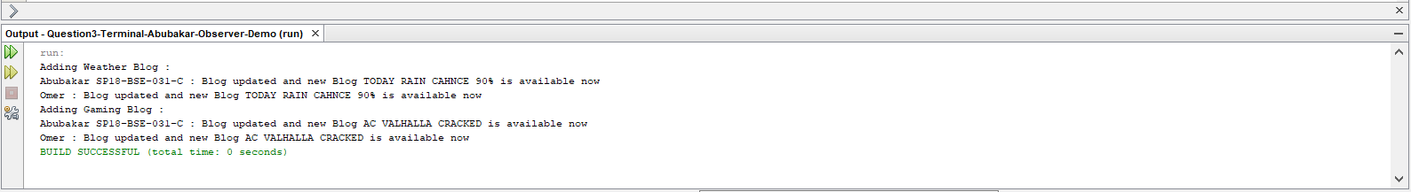

Question 4: Discuss the recent trends and new patterns in the field of design pattern as per the latest
research findings. [7]
Ans :
There are many trends, but these are the two trends, both driven by the growing popularity of functional programming (FP) languages:
1) New functional patterns
2) Design patterns considered harmful.
The FP community has not traditionally used the phrase "design pattern", but there are many patterns used in FP that will be new to OP programmers. They include richer forms of pattern matching and conditionals, including "destructuring" features (for extracting values nested in other values - i.e., fields in objects, to use OP terminology, but also elements in collections), more extensive use of recursion and iterator "patterns", such as folds, and the famous monads, such as the Maybe/Option monad. Monads are containers with specific properties and the Maybe/Option monad represents the situation where a value exists, or it does not; it replaces the need for null. In other words, your type explicitly represents the situation where a value may not be available, such as getting a value out of a map for a particular key. It is far superior to using nulls.
There are some people who claim that the idea of patterns has been made obsolete by FP. This view confuses the idea of patterns with instances, good or bad, of patterns. IMHO, the concept of reusable design ideas is and will remain perfectly valid. However, it is true that some instances of patterns, like the Visitor abomination, have been made obsolete by FP.

Patterns are solutions to recurring design problems [GHJV94, SFJ96]. In this report, to investigate the issues regarding design patterns, we move on to the current state of design patterns’ challenges, trends, and research directions. Based on studying the past and the current researches, we classify the design pattern research field into two broad categories:
• Design pattern application
• Design pattern detection and identification.
Design Pattern Application is aimed at applying pattern solutions in the software design, i.e., it is a forward engineering approach. However, the Pattern Detection and Identification is a backward and reverse engineering approach which intends to detect and identify the applied design patterns in the given source codes. As we know, a design pattern as a solution to a recurring problem has several components and constituent elements such as the pattern intent, motivation, applicability/known uses, and consequences, to name a few [GHJV94]. Thus, most of the existing pattern detection tools use other terms such as design motifs in [Gu´e07a], i.e. the solution components of design patterns which can be extracted from the source code or design model in a more tangible way. In the following, we will explore the details of these techniques through investigating their practical applications and related researches and studies.

Pattern Application:

The main drawbacks on the way of pattern application include: expertise and knowledge requirements in the application of correct design patterns; lack of formal basis and techniques to aid in the systematic pattern selection and application; and little support to verify the correctness of the applied design patterns and their relationships [Kim08, FBB+14].
Transformation-based Pattern Application:

In order to apply systematically a design pattern to a model, [Lan14] uses model transformation for the application and verification of design patterns in a design model. Here, first a model is developed regardless of any design pattern in mind and then in the next step, the produced model can be re-factored to improve its quality through the introduction of suitable design patterns. Finally, model transformation verification can be used to verify that the existing model restrictions are preserved. In order to provide qualitative and continuous services in the cloud-based systems, [AB14] applies a self-adaptive architecture based on the adaptation patterns in the form of a Pattern Language (PL) recovered from the architecture adaptation log of the underlie running system. Refactoring a design model using design patterns has been experienced in [FCSK03]. Here, based on the defined meta-model of the design pattern with matching its problem specification against the design model, refactoring automated through transformation on the level of the design pattern meta-model.

Applying PLs in Practice:

With the emergence of patterns, pattern collections and PLs in various contexts, designers are encouraged to use the PLs in a practical sense to solve common software problems as a whole [HGY14]
Question 5: Consider the following diagram and analyse which pattern is used in this scenario:
(Justify your answer)
[3]

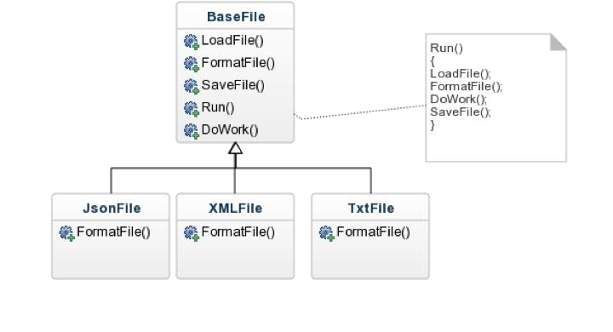
In Template Method design pattern, we define our specific algorithm in the base class. An algorithm can consist of several methods. When designing the base class, we do not know the implementation of some methods and we mark these methods as abstract so that subclasses can implement these methods. A method in the base class that uses abstract methods is called a model method.

In this model, a subclass cannot modify the base class algorithm. Subclasses can only implement some methods of the base class that are not implemented in the base class.

In the diagram above, we have a BaseFile class which defines an abstract FormatFile method. JsonFile, XMLFile, and TxtFile are subclasses of BaseFile and these classes implement the FormatFile method. The LoadFile, SaveFile, DoWork and Run methods are already implemented in the base class.

